User Acceptance Testing (UAT) Template
Date | 17 February 2026
Team ID | LTVIP2026TMIDS81120
Project Name | Smart Sorting: Transfer Learning for Identifying Rotten Fruits and Vegetables
Maximum Marks | 4 Marks

Project Overview:
Let’s see how our home.html page looks like:
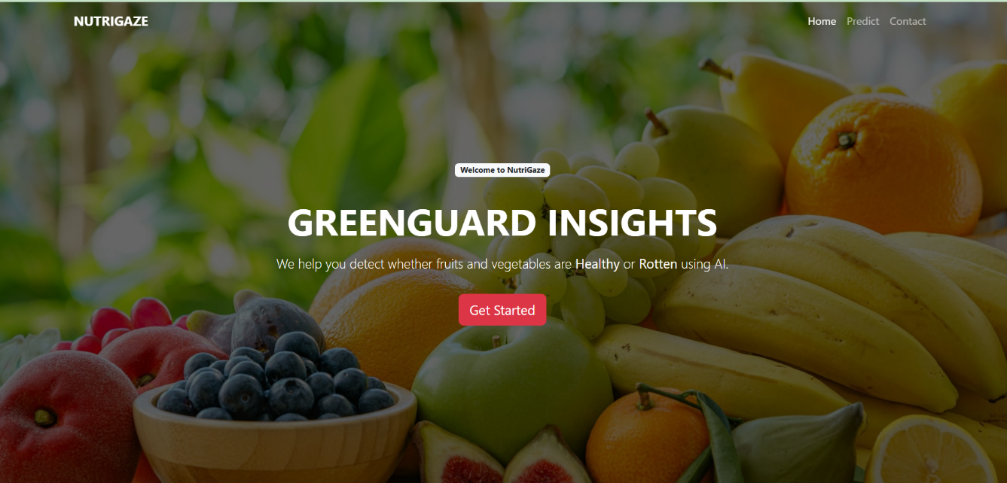

Now when you click on the “Get Started” button from the top right corner, you will be redirected to the predict.html page.
This page is where the main interaction happens. It provides a simple interface that allows users to upload an image of a fruit or vegetable for analysis. Once an image is selected and submitted, it is sent to the backend model fo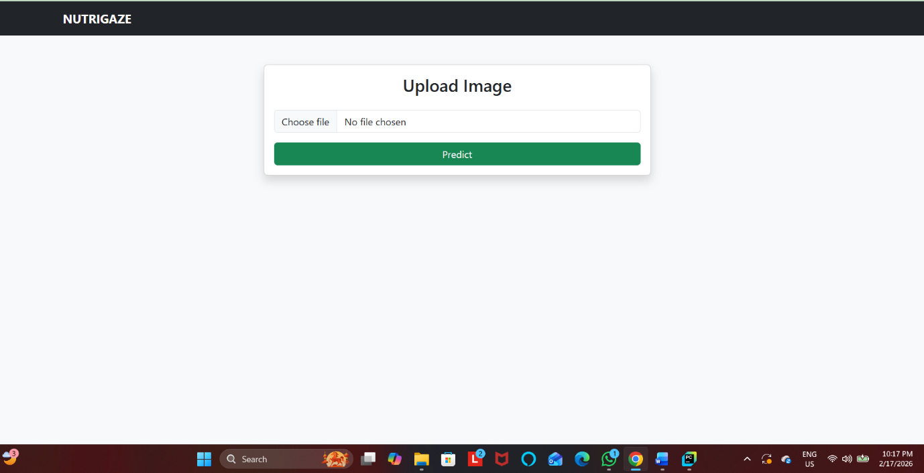r processing.

Now when you click on the Detect button, a pop-up message appears showing whether the uploaded fruit or vegetable is Fresh or Rotten, based on the model’s prediction.